St Pius X Catholic Parish Heidelberg West acknowledges the Wurundjeri people.

Fr Wayne Edwards: St Pius X Presbytery 419 Waterdale Rd Heidelberg West 3081

Tel: 9457 5794 Fax: 9457 1036 Email: heidelbergwest@cam.org.au

Exodus Community: 273 Liberty Parade Heidelberg West Tel: 9457 7593

School Principal: Barbara Gomez Tel: 9457 3776 Email: bgomez@spxhw.catholic.edu.au

_________________________________________________________________________________________________

MASS TIMES

Sundays Saturday Vigil 7pm Sunday 9am & 11.00am

Exodus Community, 12 Noon in the shed at 273 Liberty Pde, Heidelberg West

Weekdays 9am Tuesday, Wednesday, Thursday, Friday, Saturday

CONFESSIONS & ROSARY After 9am Mass on Saturday mornings

CHURCH OPEN FOR PRAYER 8.30am – 4pm on school days only

PARISH WEBSITE - pol.org.au/heidelbergwest

St Pius X Catholic Church Heidelberg West actively works to listen to, empower and protect children, and has zero tolerance for child abuse and neglect.

PLEASE LOOK AFTER YOUR CHILDREN WHILE MASS IS IN PROGRESS
SAINTS/FEAST DAYS FOR THE WEEK
- Monday 21 – St Pius x
- Tuesday 22 – The Queenship of the Blessed Virgin Mary
- Thursday 24 – St Bartholomew

Reflection “For the gifts and the call of God are irrevocable.”-Romans 11:29
God has a special mission in mind for each of us. He has given us the gifts we need to accomplish that mission. We are called to be good stewards by using those gifts to do the work that He has planned for each of us. If we deny our gifts or fail to use them as God calls us to use them, then some part of His work will be left undone. Each of us has a part in God’s salvation plan.

Next Sunday: August 27
 | Reader | Special Ministers
Saturday 7:00pm | Margaret Scroggie
Sunday 9:00am | Julie Gill
Sunday 11:00am | Valerie Lennox
NEXT SUNDAY’S READING – 21ST SUNDAY IN ORDINARY TIME
Is 22:19-23: Ps 137:1-3, 6, 8: Rom 11:33-36: Mt 16:13-20

ST VINCENT DE PAUL WINTER APPEAL
Inviting parishioners to donate non-perishable food items over the coming weeks. Your donations will be distributed to needy families by the local St Vincent De Paul Society conference. Winter woolies will also be accepted: scarves, socks, gloves, jumpers, blankets. Please place items in basket at foot of sanctuary.

FOLLOW US ON FACEBOOK: St Pius X Catholic Parish
WEBPAGE: pol@cam.org.au/heidelbergwest

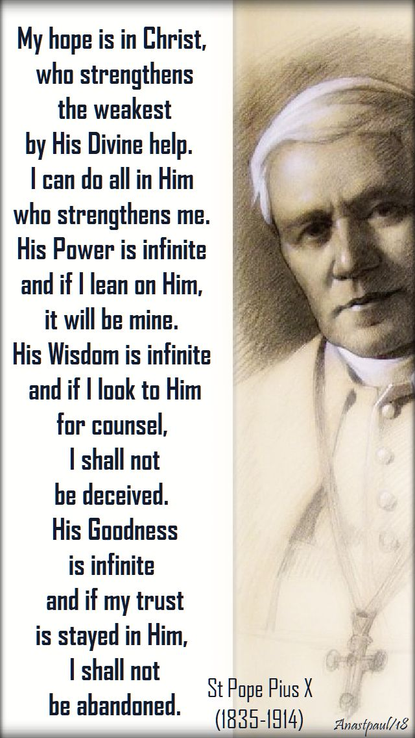
EXPERIENCE TAÍZÉ
Friday, 25 August, 6pm-7pm at St Pius X Church
Come and experience this calming, quieting, welcome respite from the hustle and bustle of life…. All are welcome!
VICTORIAN GOVERNMENT ENERGY REBATE
On 24 March 2023, a new round of the Power Saving Bonus program commenced. Victorian households are now able to receive a new $250 payment, including any households that received a payment through previous rounds of the program. Applications must be made online at https://compare.energy.vic.gov.au/ for assistance if you do not have a computer please contact Junia at the Parish office on 9457 5794
SENIORS GET TOGETHER – AUGUST
All seniors (over 55) are more than welcome to join us at our monthly gatherings. Join us on Wednesday 20th September more details to come
CATHOLIC CARE VICTORIA SUNDAY APPEAL
Thank you from CatholicCare Victoria CatholicCare Victoria is deeply grateful for the support of our parish during last week’s CatholicCare Victoria Sunday Appeal. Because of the generosity of our parish community, CatholicCare Victoria can continue to ensure that vulnerable individuals and families in our community have the opportunity to live life to the full. Thank you for helping those in need! For more information about CatholicCare Victoria, please visit: www.catholiccarevic.org.au

Prayers for the Sick: Hannah Steane
For the recently departed: For the repose of the souls of the faithful departed
Anniversary of Death: Benjamin & Therese Hennequin, Wilfred Anderson, Remo Quinzi, Claudia Ty, Richard Rapsing, Michael Kelly, Eugenio Mazzanti, Gwen Gunn, Bill Cronin, Alessandro De Paulis, Marie King, Antonio Calabrese

